SPECIFICATION CHANGES MADE IN ADSP-SC582,SC583,SC584,SC587,SC589, 21583, 21584, 21587 DATA SHEET, REVISON B

==================================================================================

Rev A:

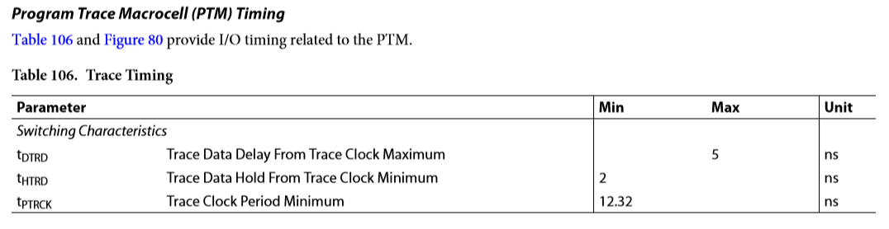

Rev B:

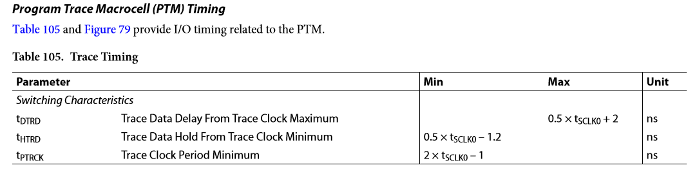

FOR THE PCIE POWER SUPPLIES, NEW FOOTNOTE #2 HAS BEEN ADDED:

